# School of Computer Science

**UNIVERSITY OF PETROLEUM AND ENERGY STUDIES DEHRADUN, UTTARAKHAND**



Continuous Integration and Continuous Delivery Lab

# Lab File (2023-2024)

**for**

**5th Semester**

**Submitted To:**

Dr. Hitesh Kumar Sharma

**Submitted By:**

Siddhanth Verma

B. Tech. CSE [DevOps] 500094460

R2142210766

B2- Devops (Non-Hons)

**LAB EXERCISE - 1**

**Aim:**

## Create a Maven Project in eclipse.

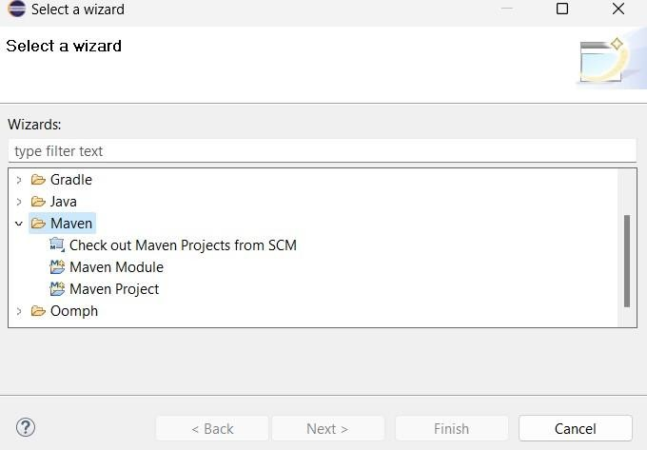

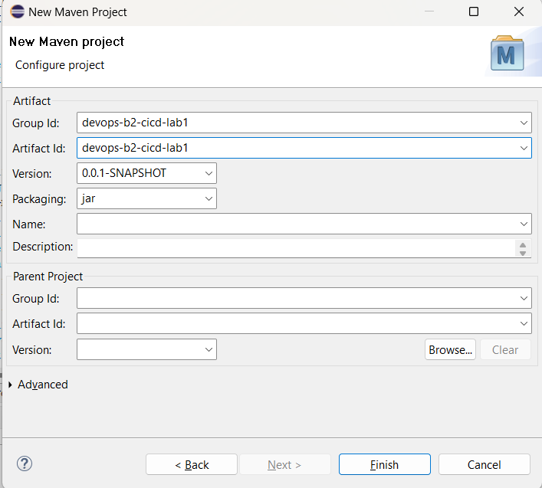

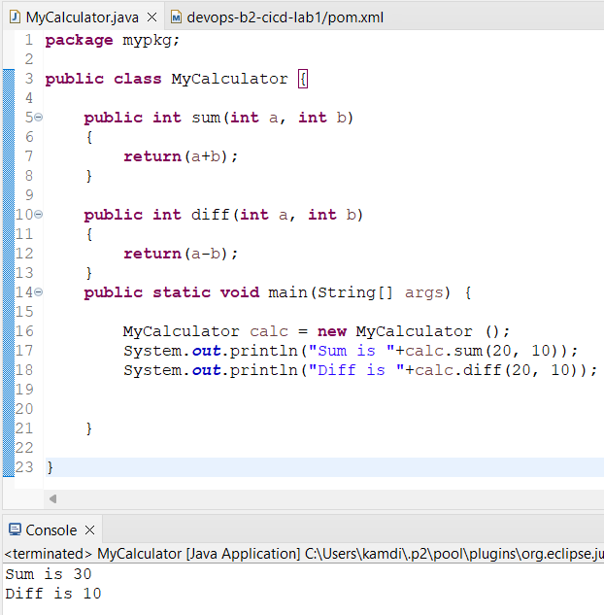

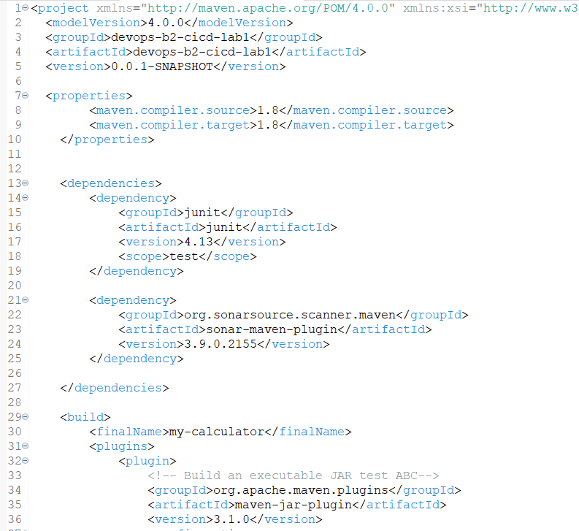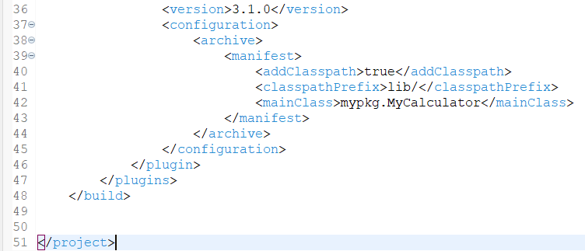

1. **Push project on github.**

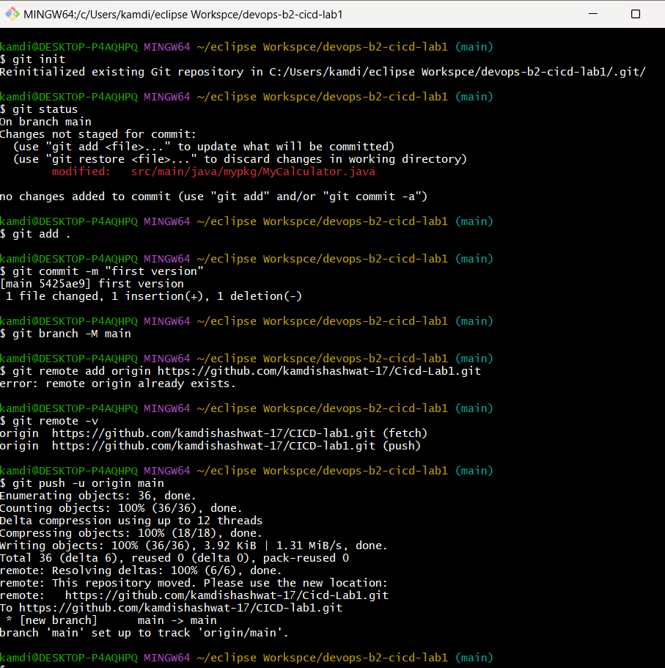

## Start Jenkins and add maven Integration Plugin and create a maven project name as “Cicd-lab1” and add URL of our repo in github and configure it.

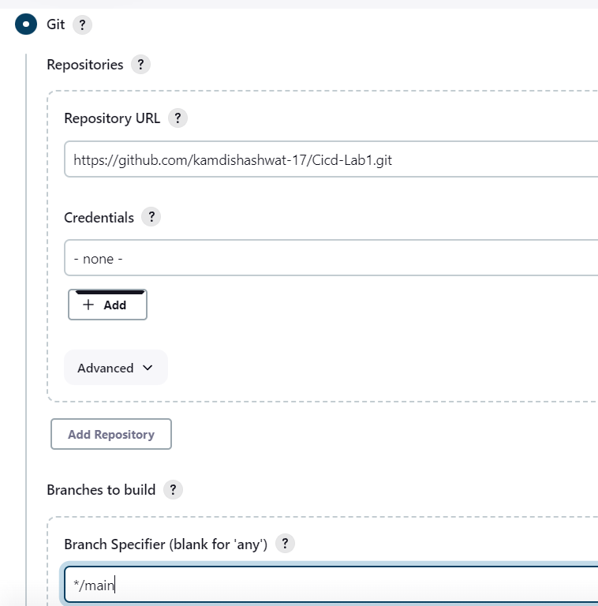

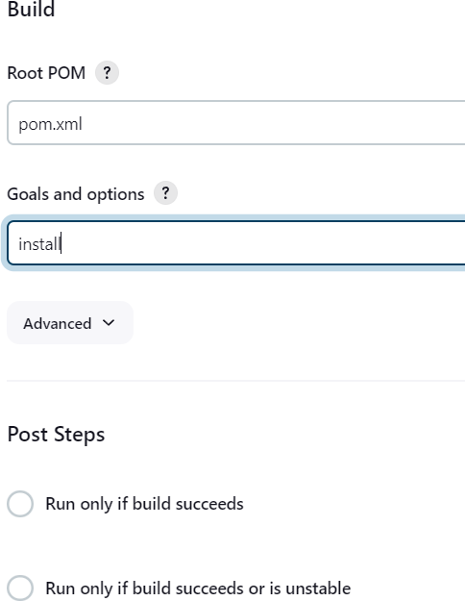

1. **Now Build it.**

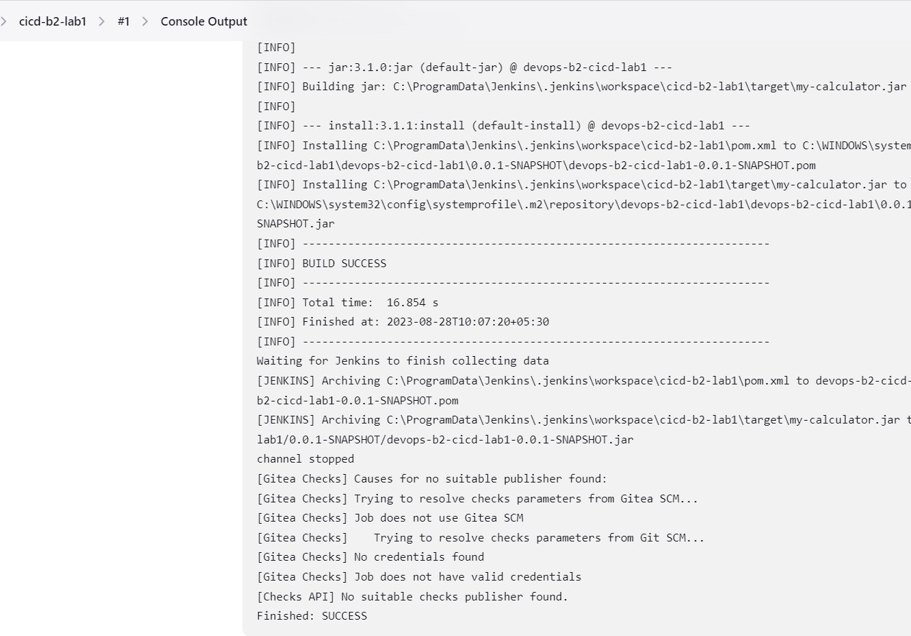

## edit the code and add poll scm in jenkins configuration then again commit and push it.

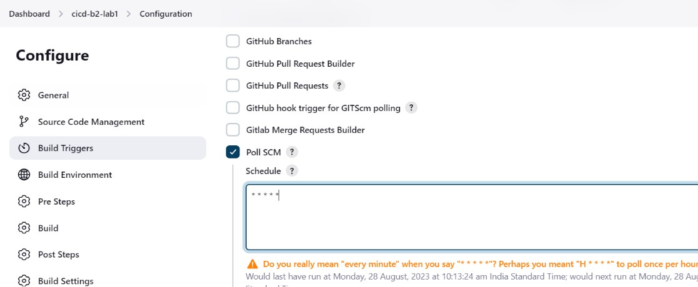

1. **After push we can see it will make automatic build.**

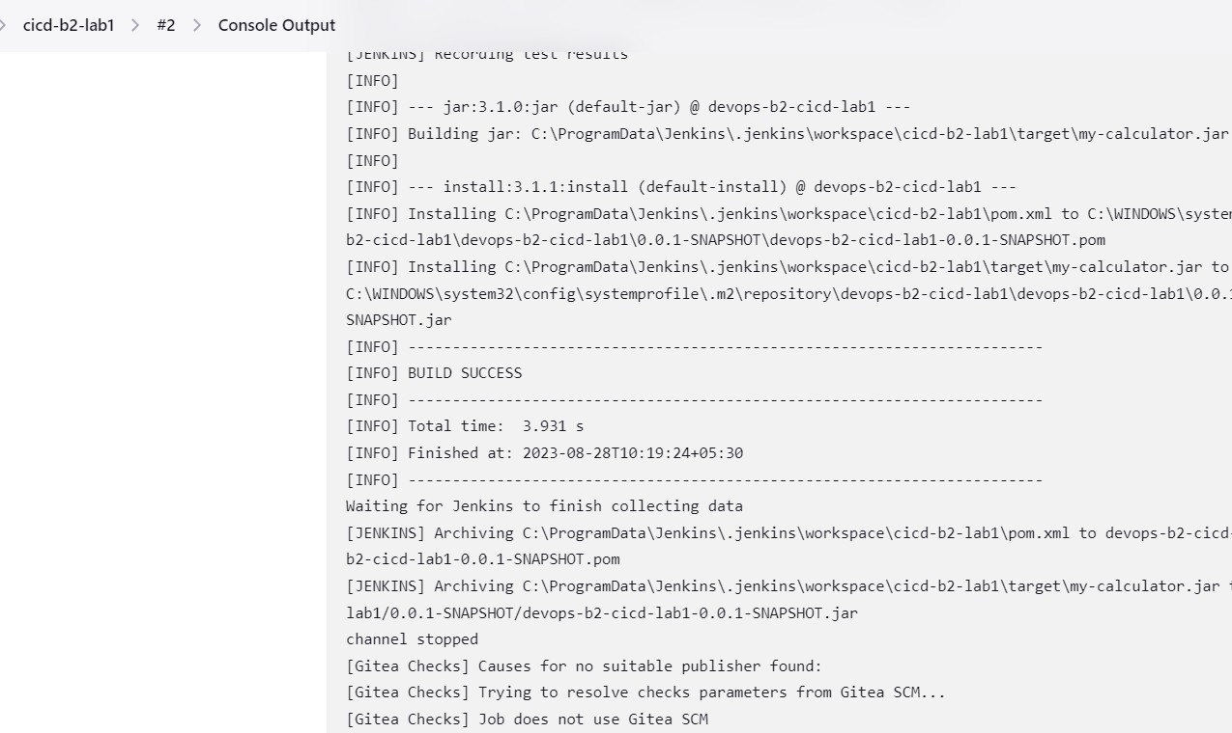

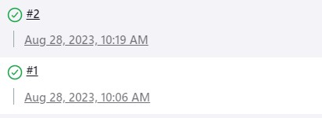

# EXPERIMENT – 2

|  |
| --- |
| Name: - Siddhanth Verma |
| Batch – 2 [DevOps Non-Hons] |
| SAP ID- 500094460 |
| Subject – Continuous Integration and Continuous Delivery Lab |

### Aim: Creating a Jenkins Pipeline with a Jenkins file.

1. **Create a Maven Project in eclipse.**



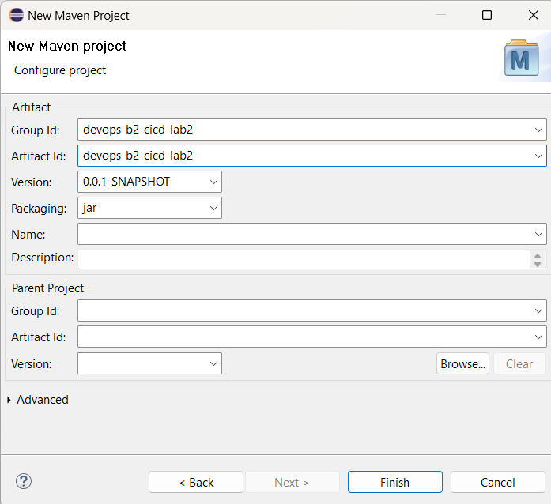

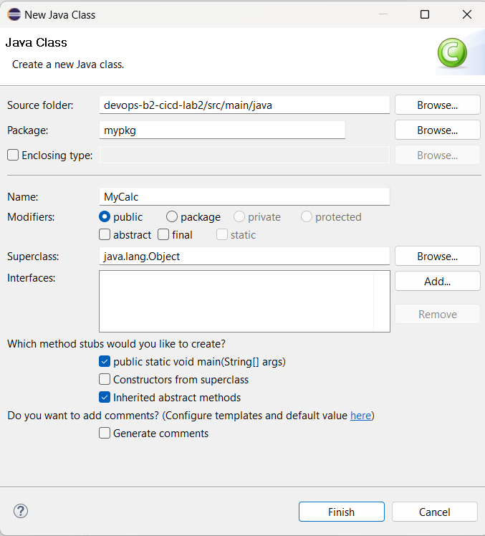

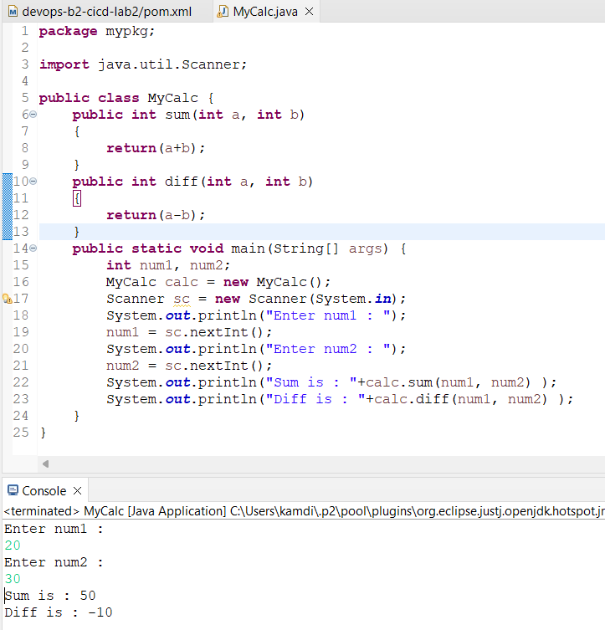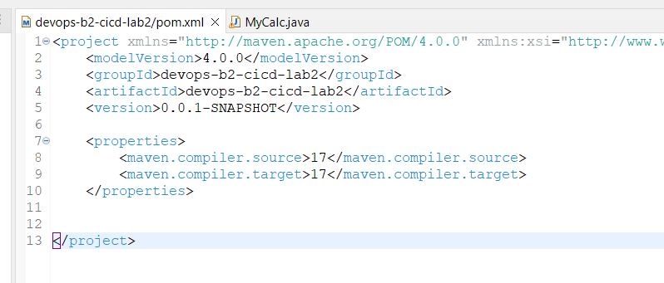

1. **Make a repo name as “CICD-Lab2_Jenkinsfile” and Push project on github.**

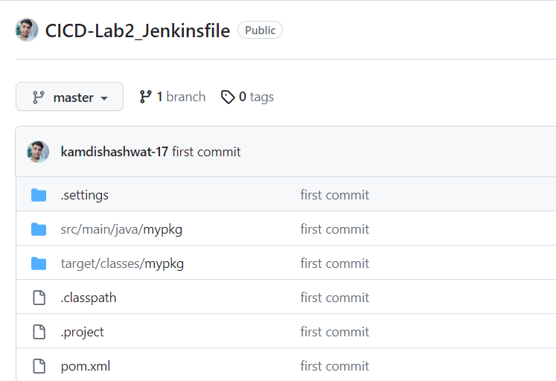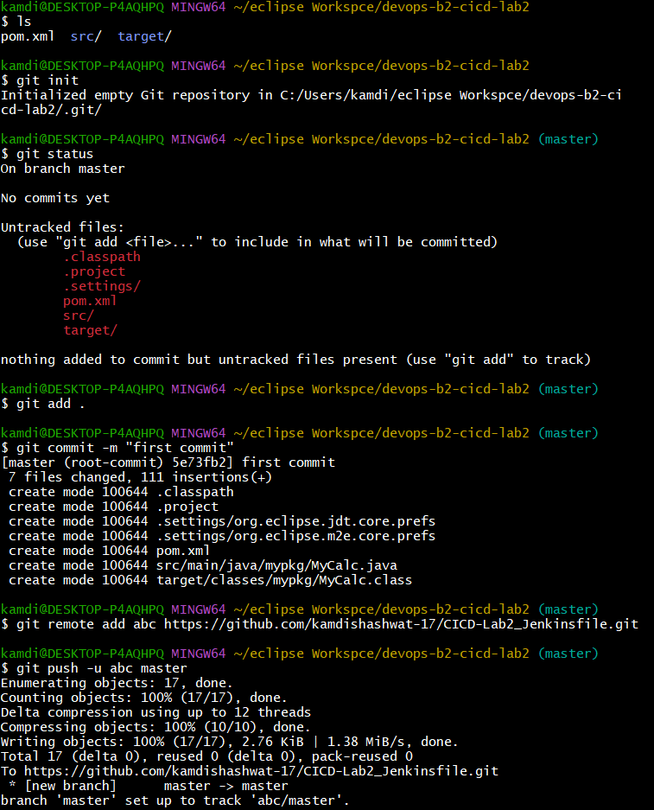

1. **Add Maven integration and Git plugin in Jenkins , configure repo and make a build**

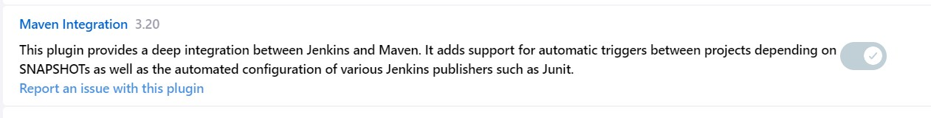



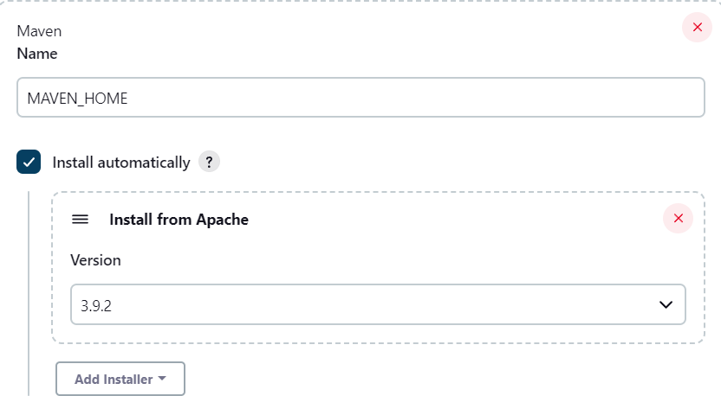

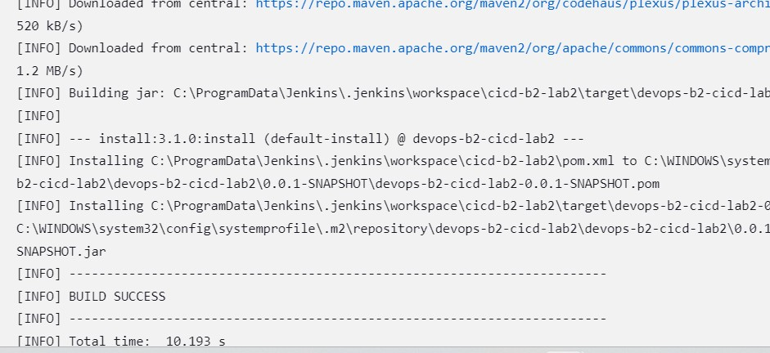

1. **edit the code ,add mul funcion and add poll scm in jenkins configuration then again commit and push it.**

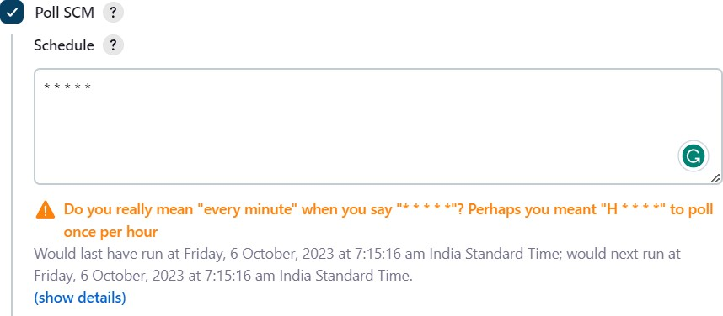

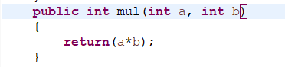

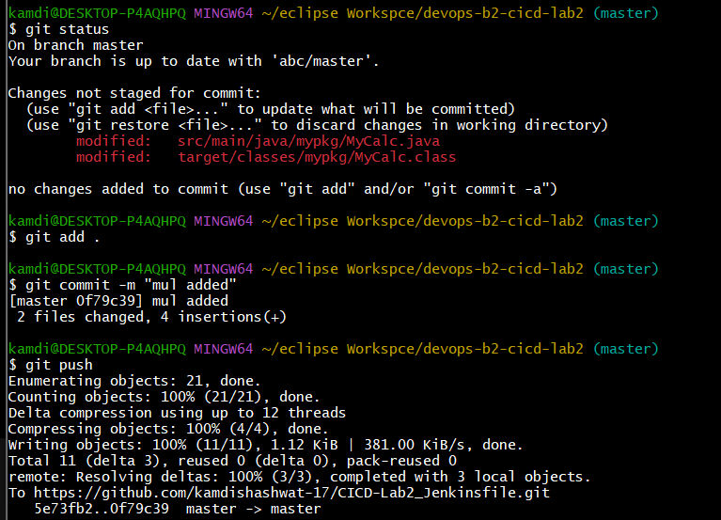

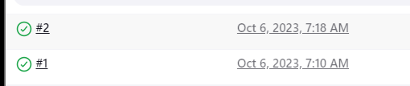

1. **Add Jenkins file then commit and push it , In Jenkins make pipeline add configure it. When you create a pipeline. The pipeline will start.**

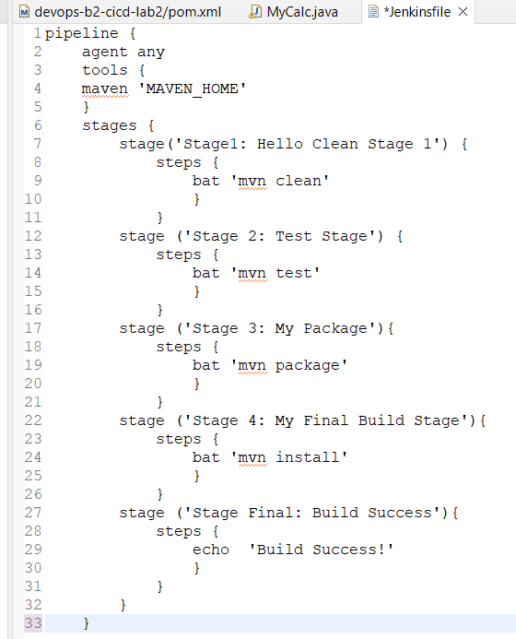

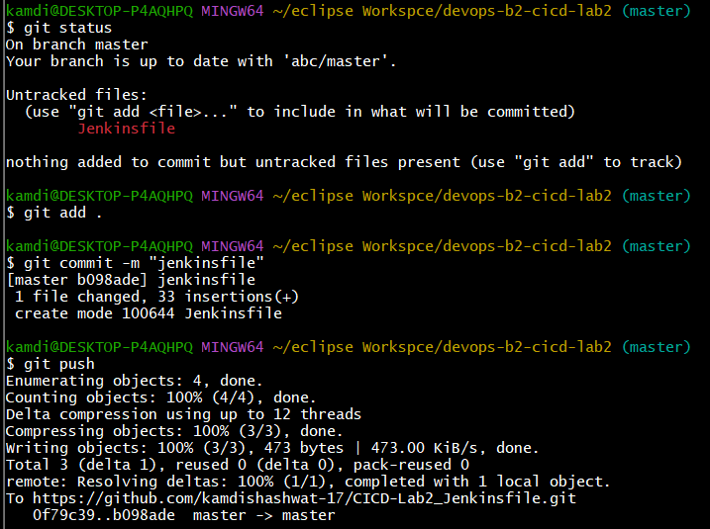

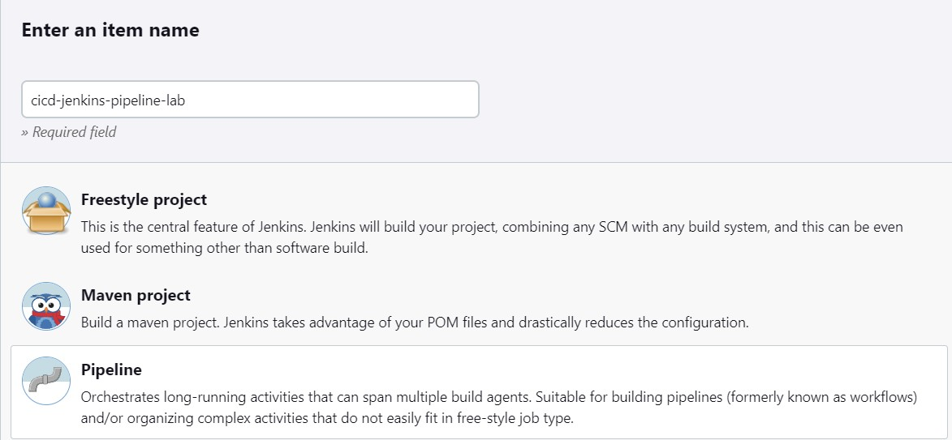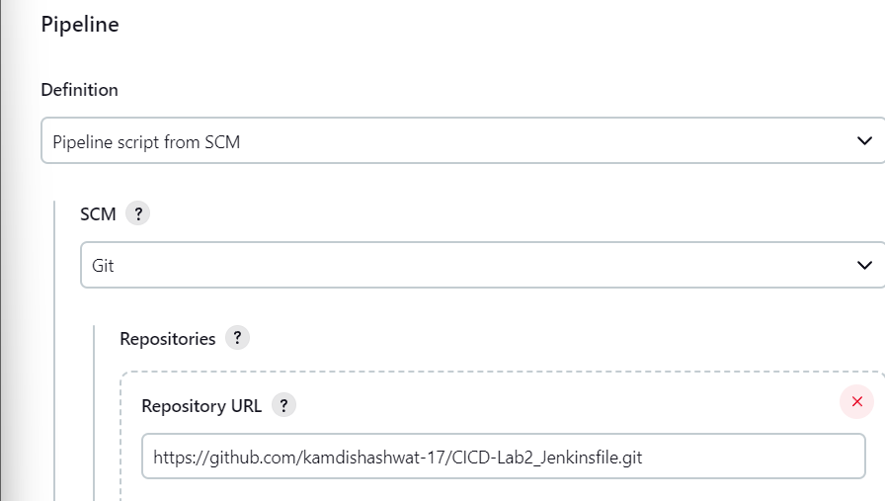

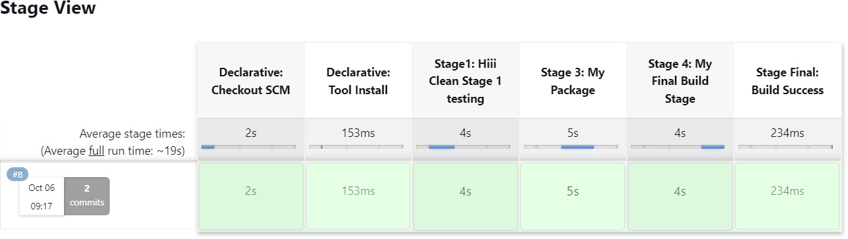

# EXPERIMENT – 3 and 4

|  |
| --- |
| Name: - Siddhanth Verma |
| Batch – 2 [DevOps Non-Hons] |
| SAP ID- 500094460 |
| Subject – Continuous Integration and Continuous Delivery Lab |

## Aim: Maven Build using GitHub Actions

1. Push our file on git repo name as CICD-lab3 which contain class file,dockerfile,pom.xml file and so on.

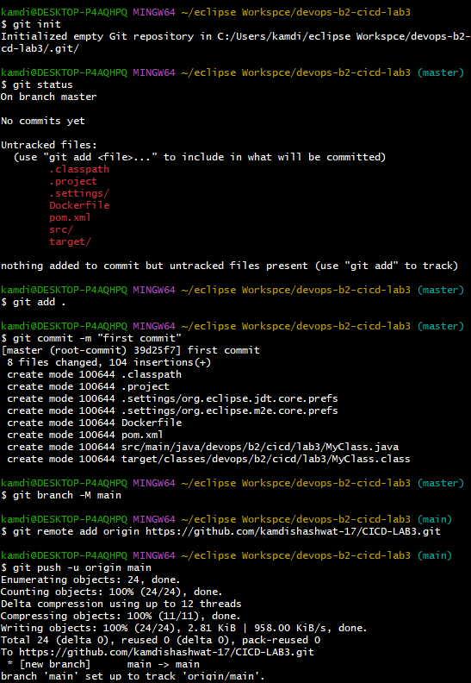

Docker file

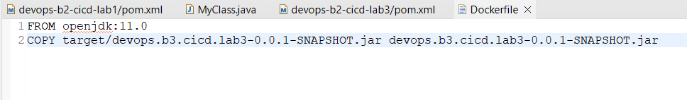

MyClass.java file

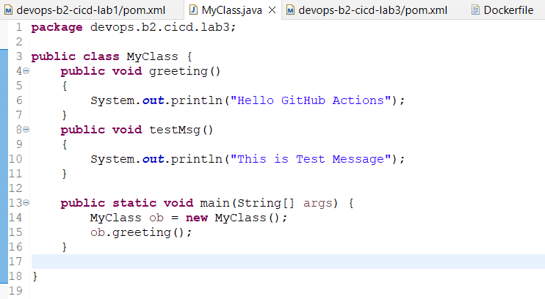

Pom.xml file

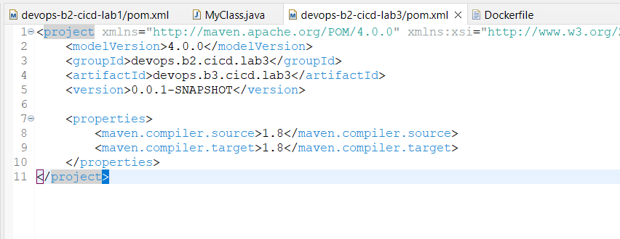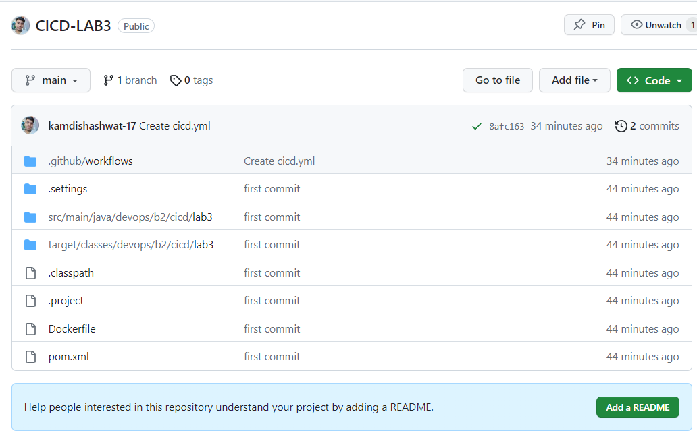



1. **Create a GitHub Actions Workflow name as cicd.yml and click on commit and push changes.**

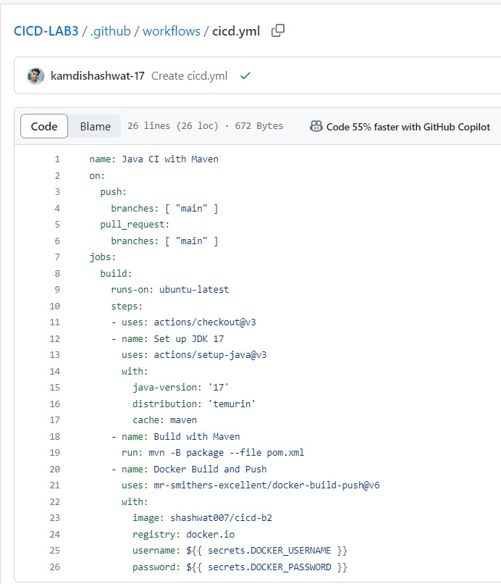

1. **Check the Workflow Status in that you will notices that our build has been completed and build images has been visible in our docker hub .**

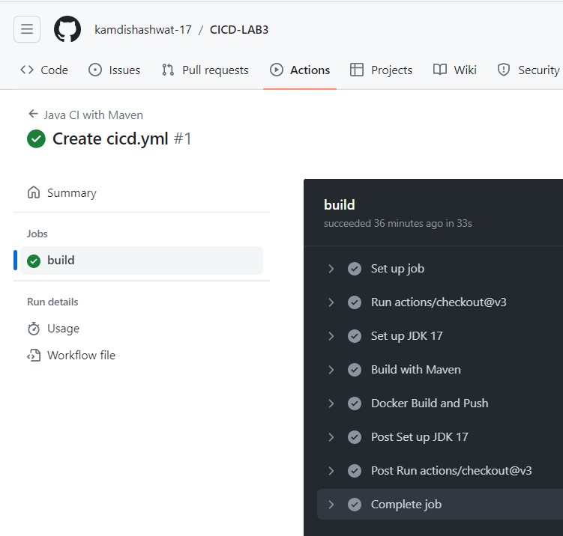

1. **Build image in docker hub**

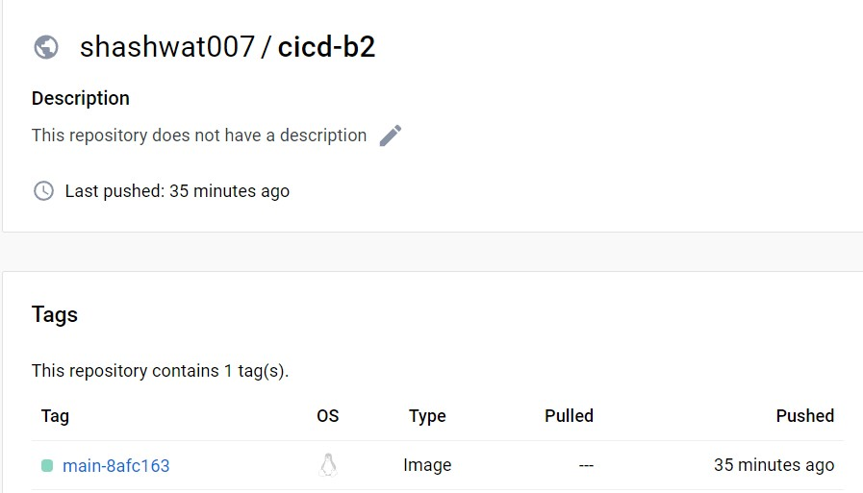

# EXPERIMENT – 4

### Aim : - Docker build and push using Github actions.

1. **Add Docker Hub Credentials to GitHub Secrets**

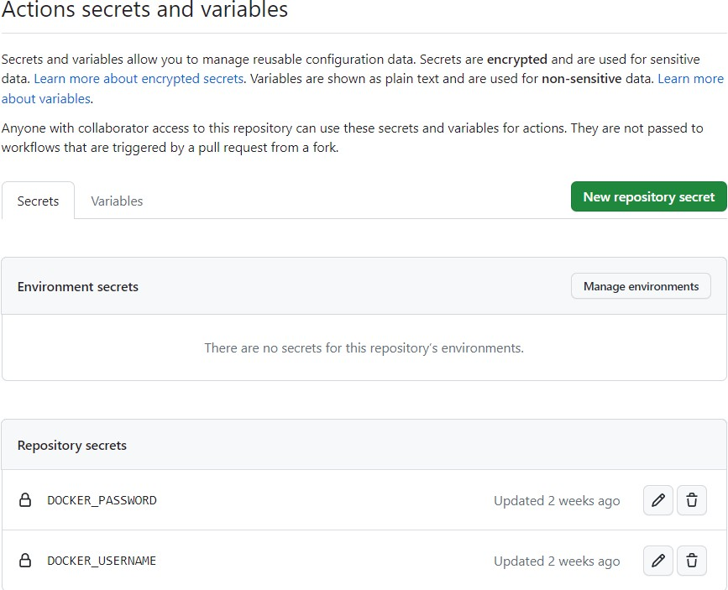

1. **Commit and Push Changes**
2. **Check the Workflow Status in that you will notices that our build has been completed and build images has been visible in our docker hub .**



4] Build image in docker hub and docker command in a public view.

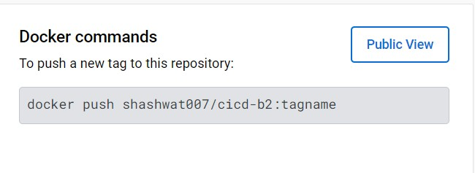

# EXPERIMENT – 5

|  |
| --- |
| Name: - Siddhanth Verma |
| Batch – 2 [DevOps Non-Hons] |
| SAP ID- 500094460 |
| Subject – Continuous Integration and Continuous Delivery Lab |

### Aim: Master/Slave concept in Jenkins

1. Create Salve1 and Slave2 folder in your Local drive.

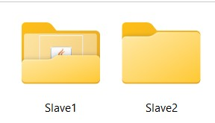

1. Create a New Node and assign node name as Slave1.

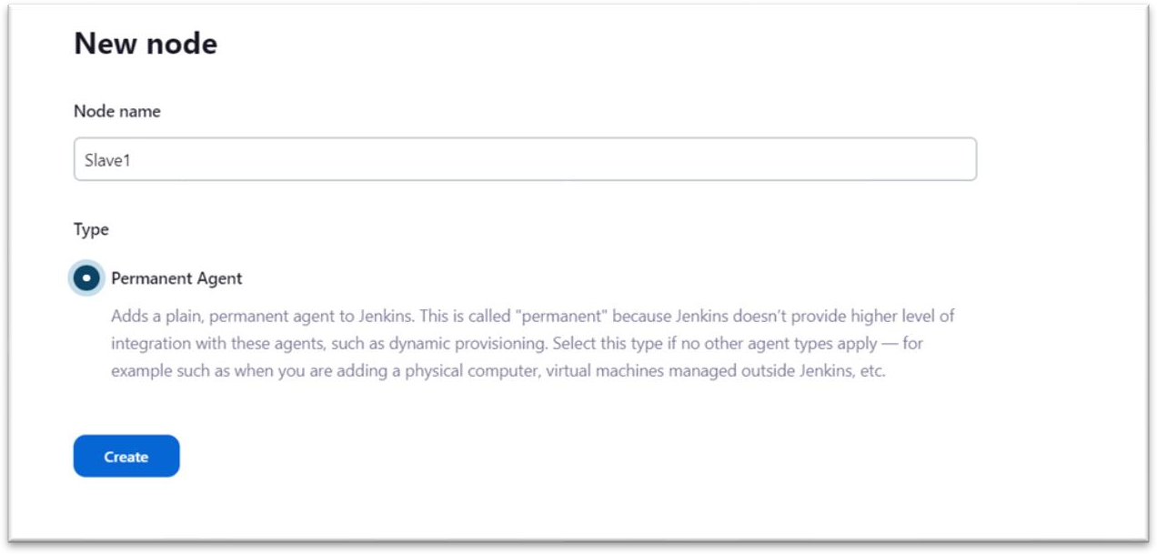

1. Run Agent slave1 command on our command line windows.

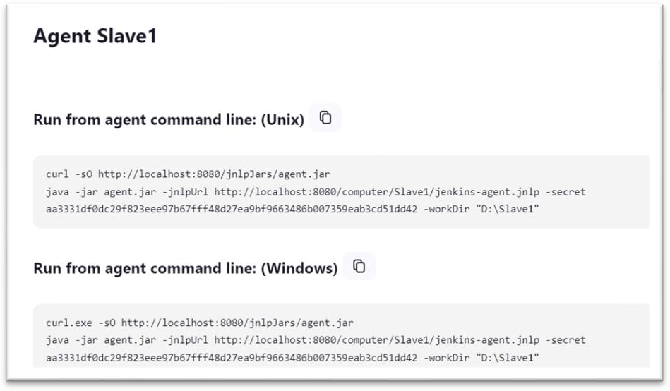.

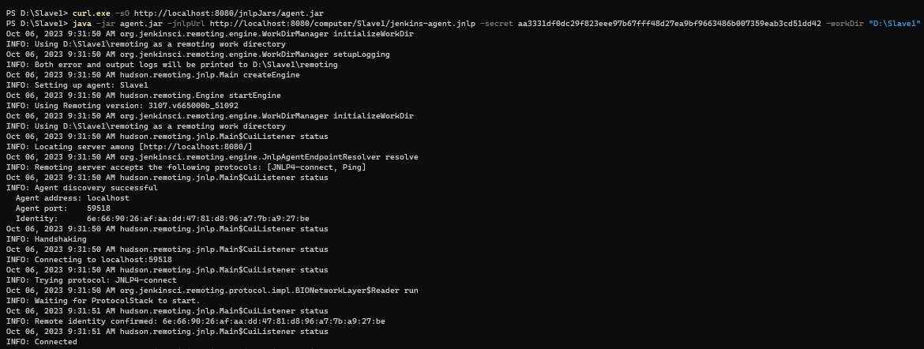

1. On your Jenkins create a new maven project name as cicd-lab5.

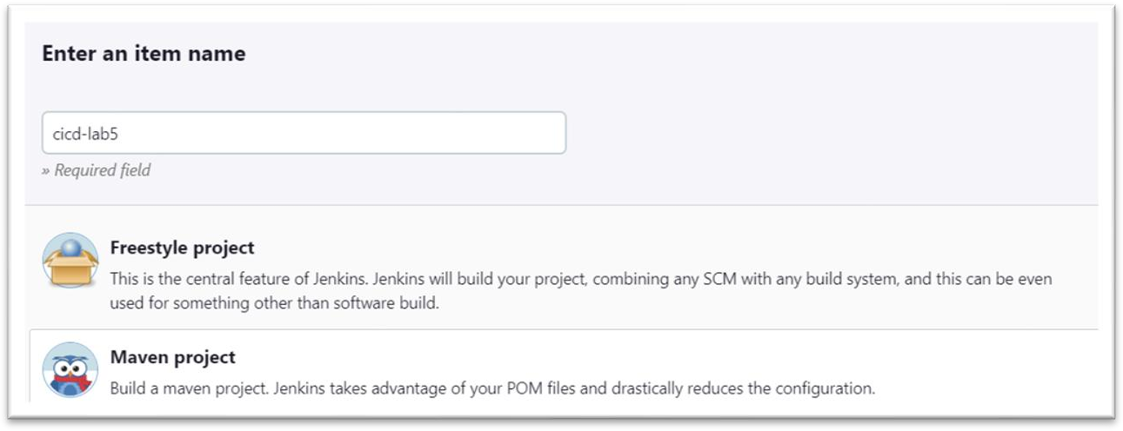

1. Configure it.

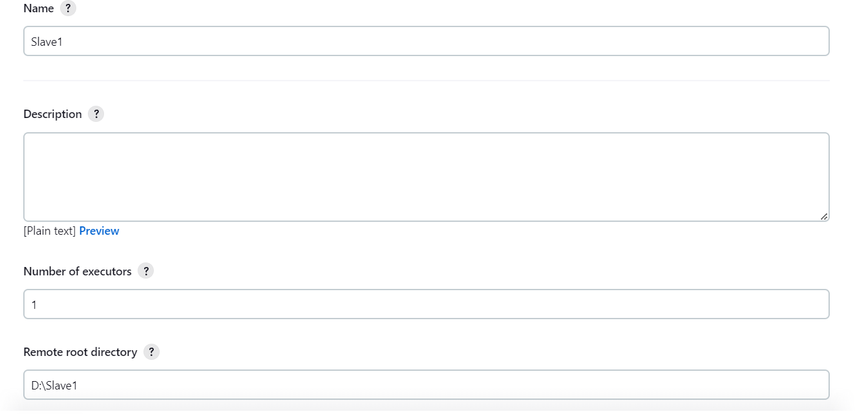

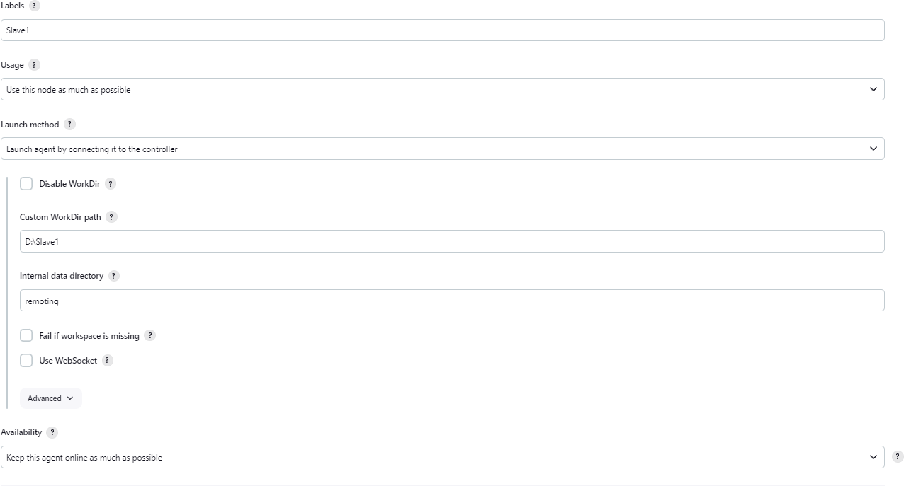

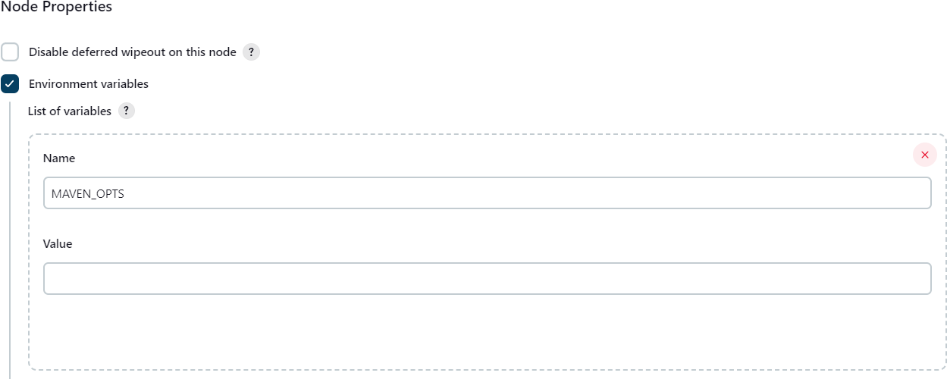

1. Make a build and check the output and Node.

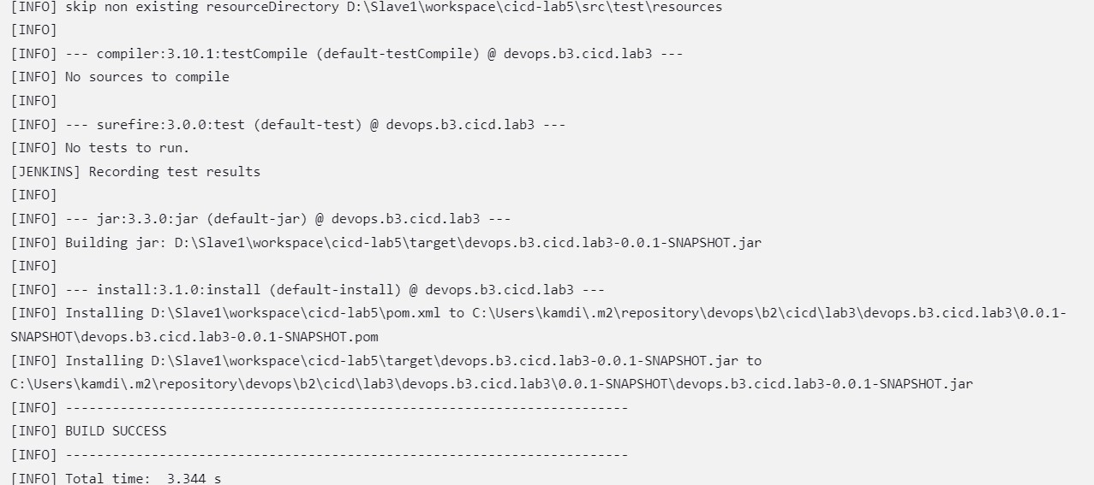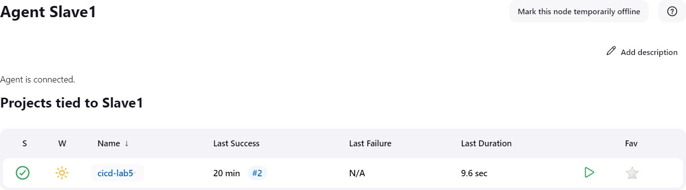

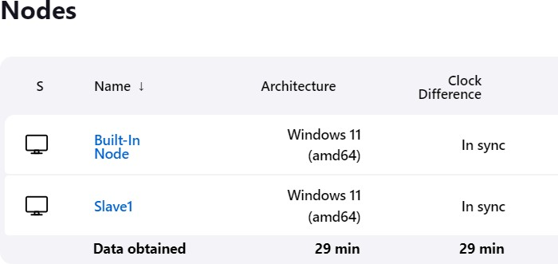

# EXPERIMENT – 6

|  |
| --- |
| Name: - Siddhanth Verma |
| Batch – 2 [DevOps Non-Hons] |
| SAP ID- 500094460 |
| Subject – Continuous Integration and Continuous Delivery Lab |

### Aim: Job Chaining in Jenkins

1. Creating Jobs, such as Job1, Job2, Job3 to stimulate job chaining and sequential execution.

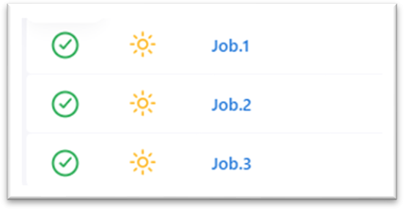

1. Configure Job Dependencies.

**Job.1 Configuration:**

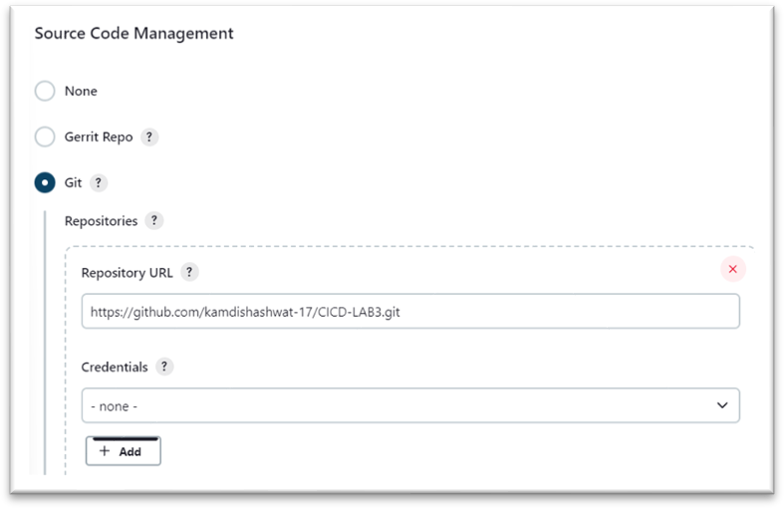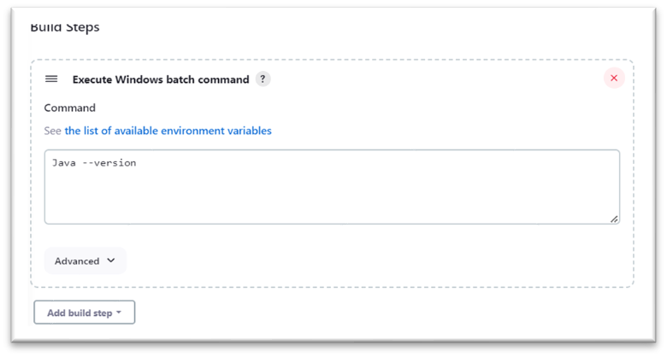

**Job.2 Configuration:**

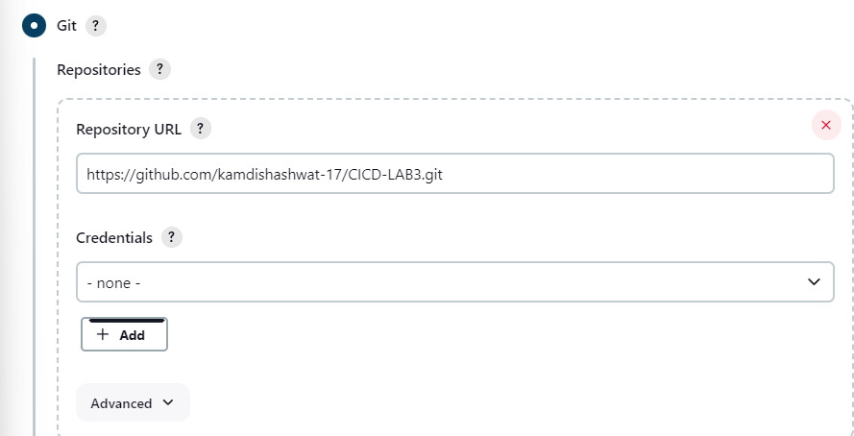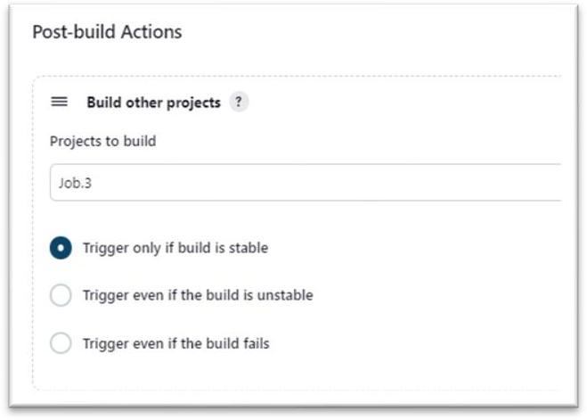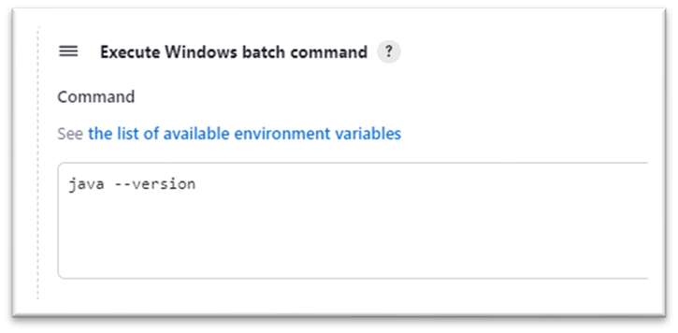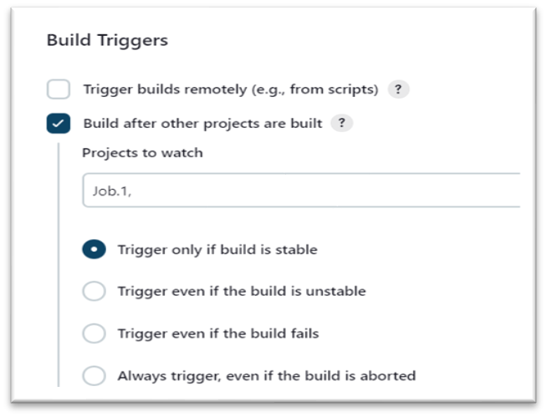

**Job.3 Configuration:**

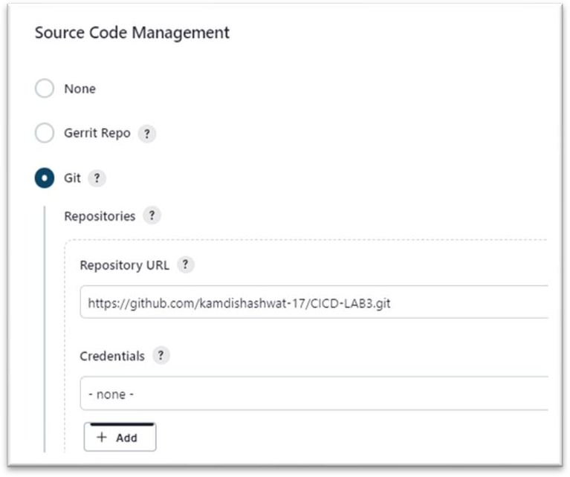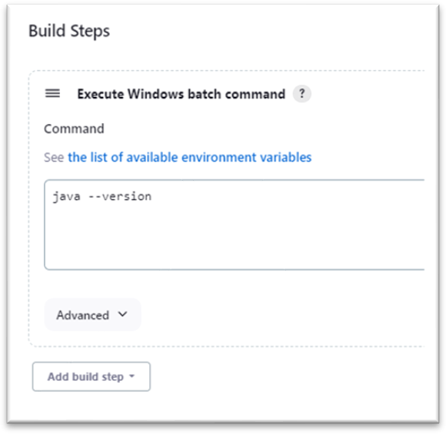

1. Setting Up Build Triggers and make the Build.

**Job.1:**

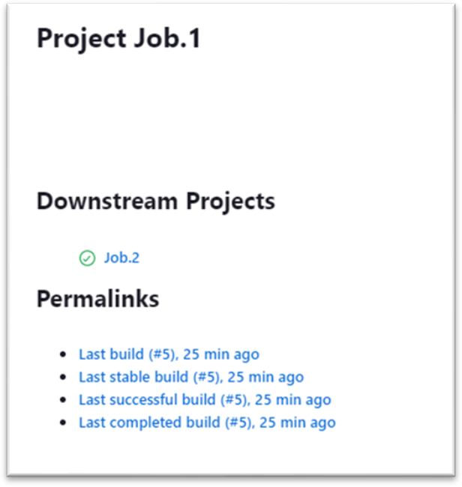

**Job.2 :**

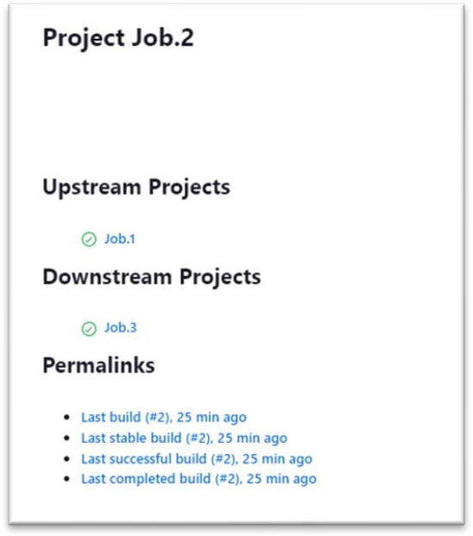

**Job.3 :**

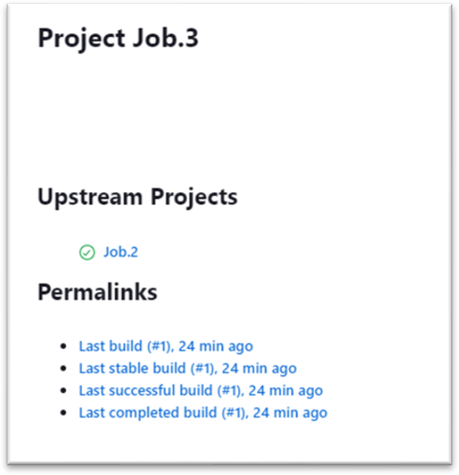

1. Viewing Console Output and Logs.

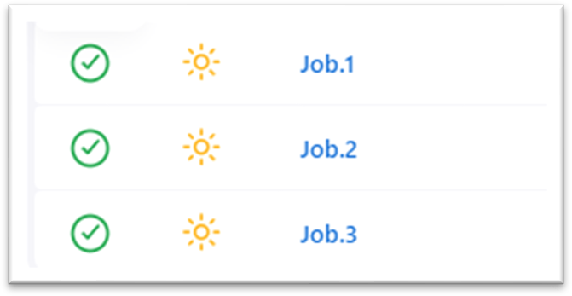

# EXPERIMENT – 7

|  |
| --- |
| Name: - Siddhanth Verma |
| Batch – 2 [DevOps Non-Hons] |
| SAP ID- 500094460 |
| Subject – Continuous Integration and Continuous Delivery Lab |

### Aim: Email Notification in Jenkins

1. Create a “App Password” from our google account setting.

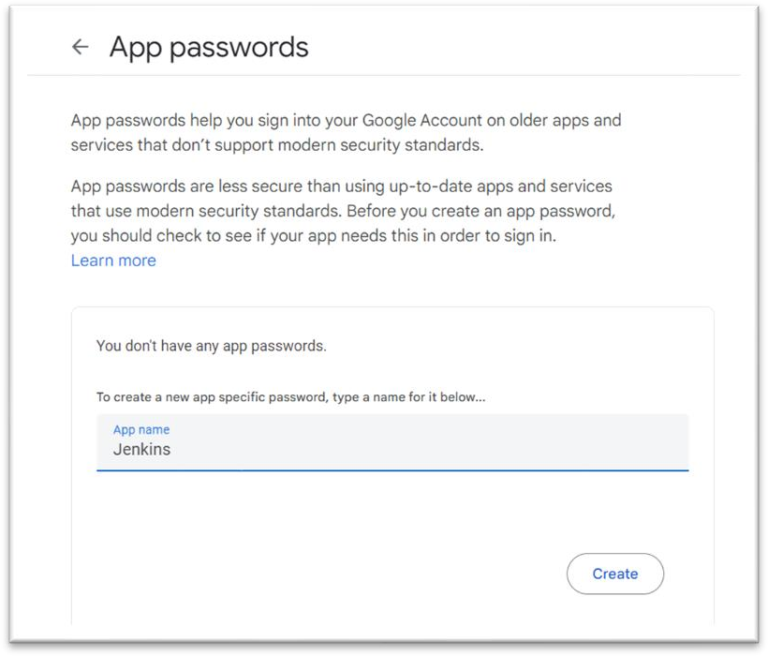

1. Installing Email Notification plugin.

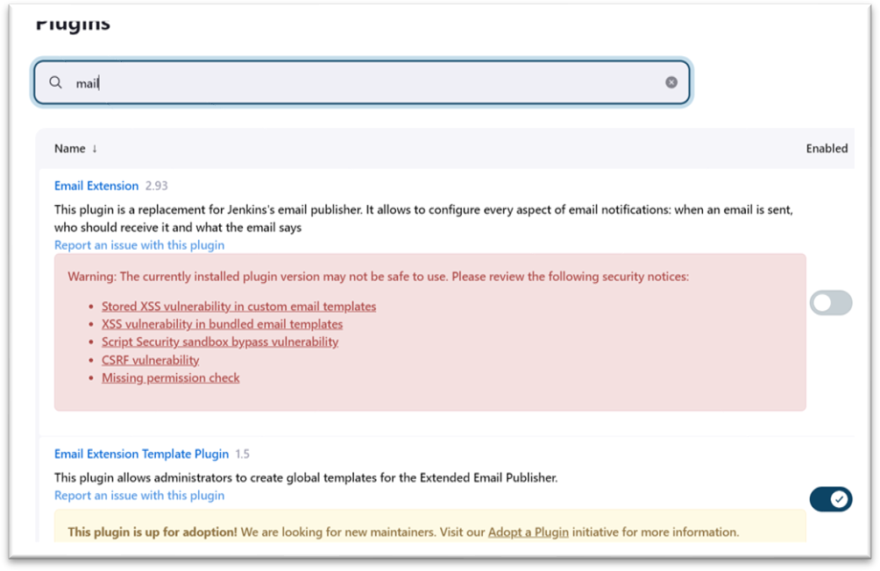

1. Configure SMTP Server by going to Dashboard > manage Jenkins > System > Email notification.

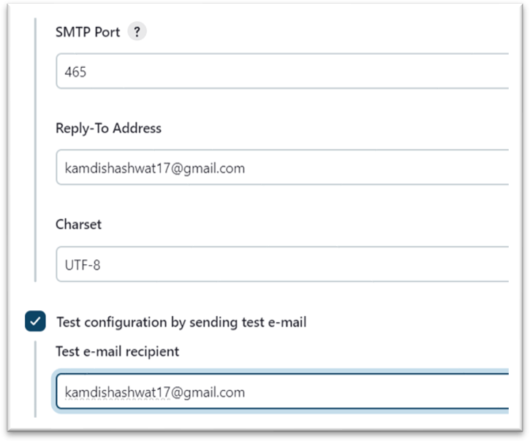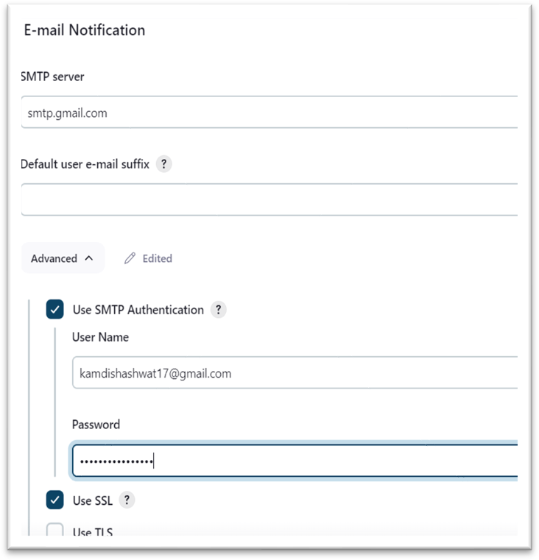

1. Create a maven project, configure it and make a build.

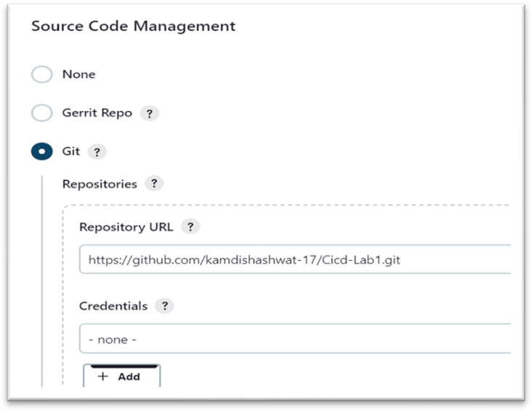

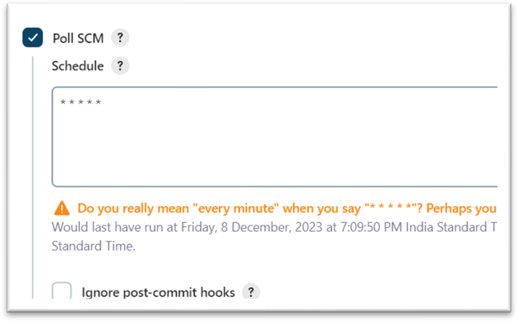

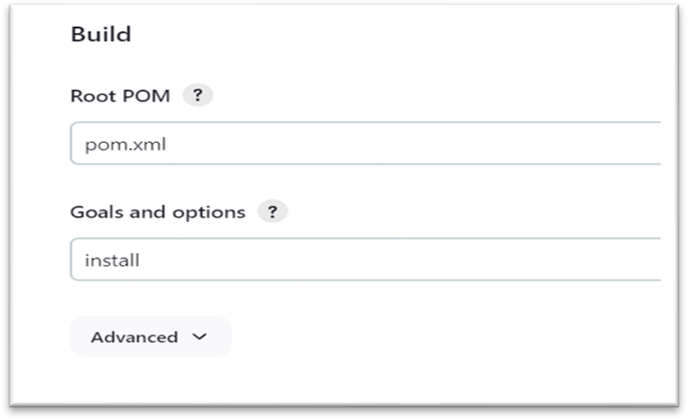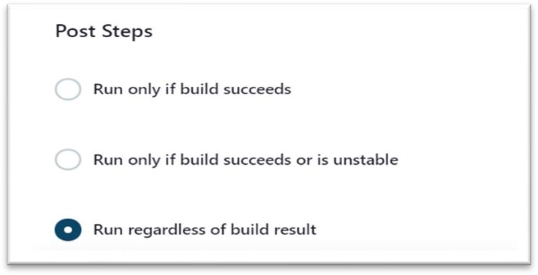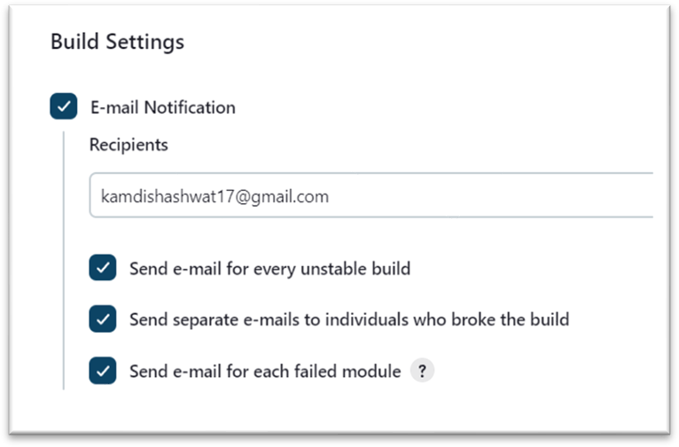



4] Check the Build and test the mail by intentionally failing a build.

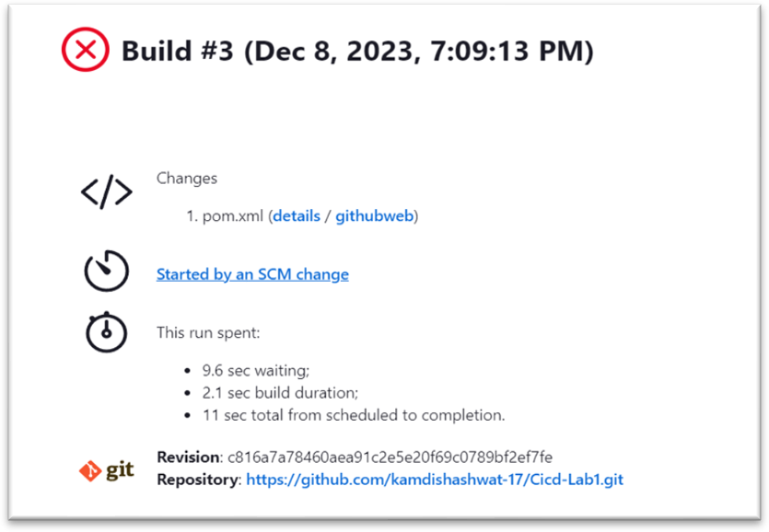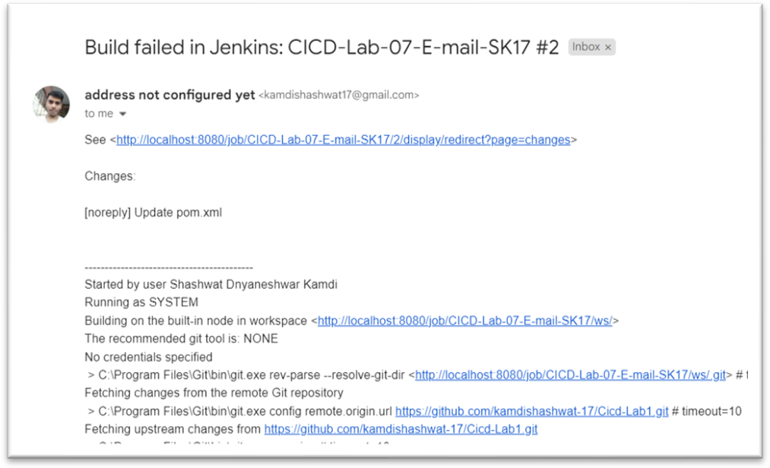



# EXPERIMENT – 8

|  |
| --- |
| Name: - Siddhanth Verma |
| Batch – 2 [DevOps Non-Hons] |
| SAP ID- 500094460 |
| Subject – Continuous Integration and Continuous Delivery Lab |

### Aim: Remote Triggering of a Parameterized Build

1. Open manage Jenkins and install “Build with parameters” Plugin.

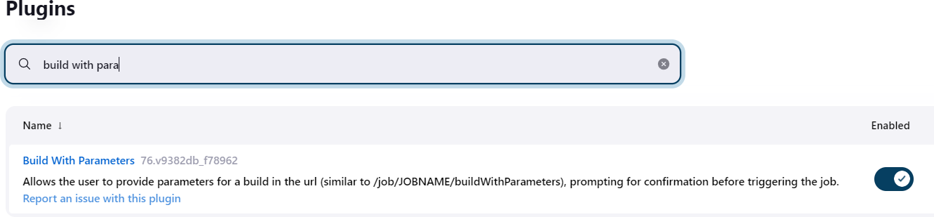

1. Select the **Freestyle project** as the build job type.

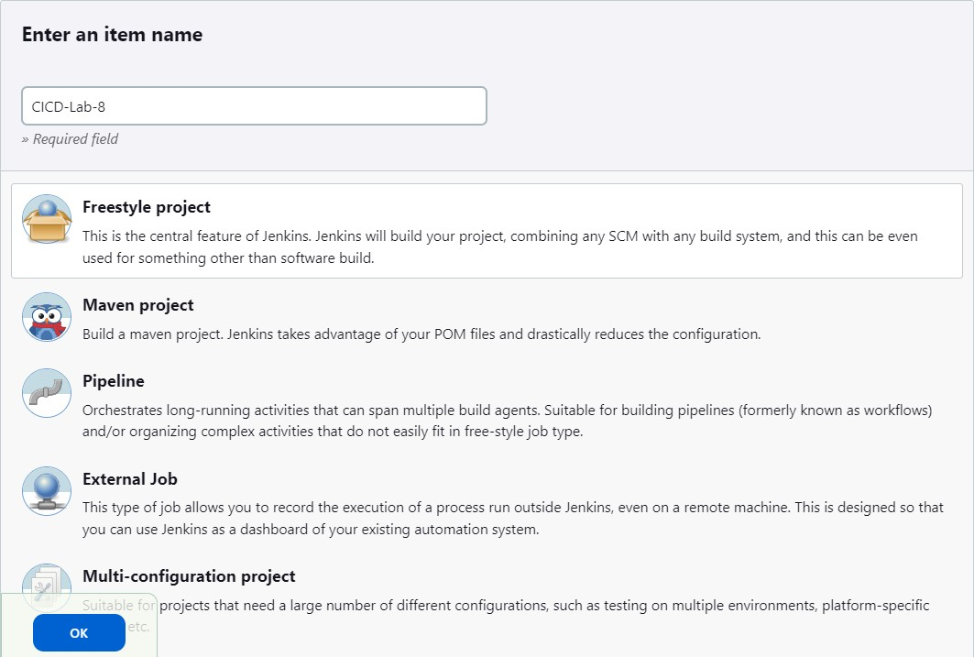

1. Configure as per Remote Triggering of a Parameterized Build.
2. Configure Global Security.

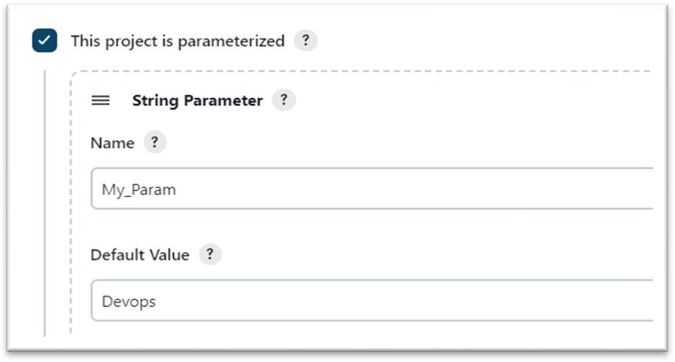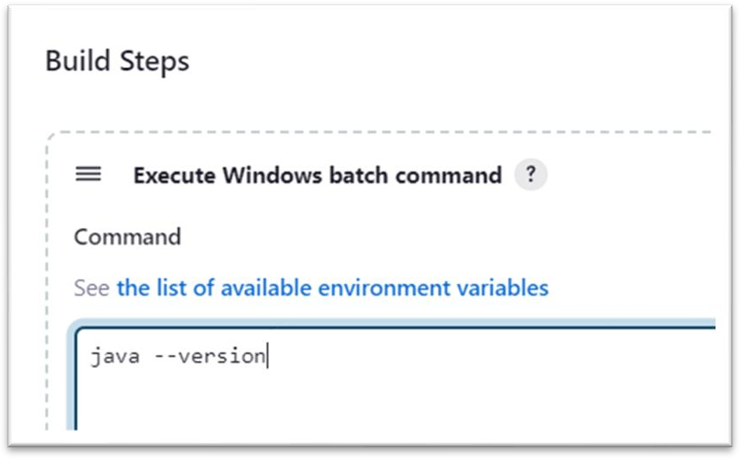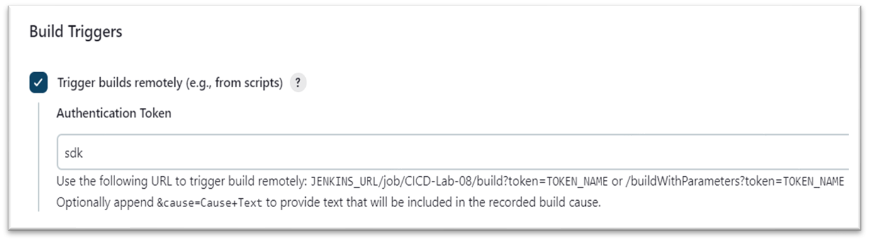

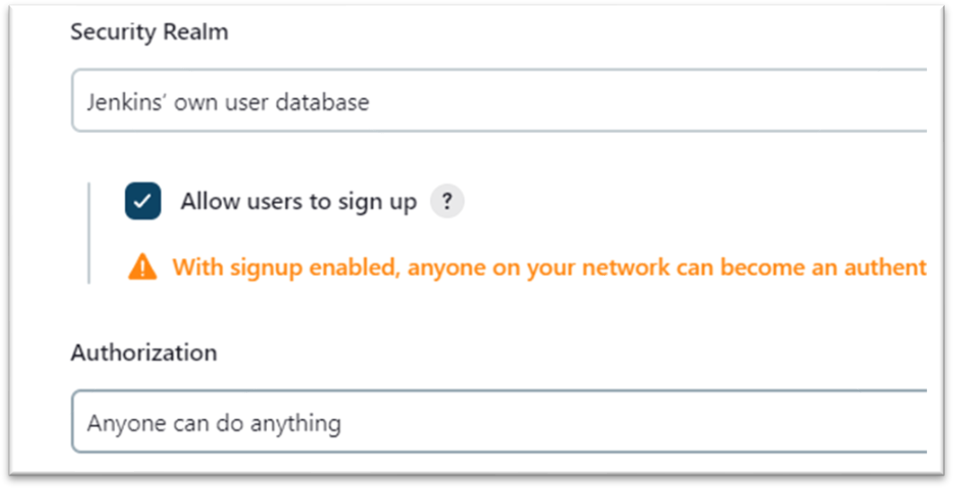

1. “curl -X GET <YourJenkinsJobUrl>/buildWithParameters?token=Sam”.Configure as per your URL and run it on Command Line.



1. Check the Console Output.

